DATA ANALYTICS | PROFESSIONAL PROJECT DOCUMENTATION
Data-Driven- Airbnb
Market Analysis
An End-to-End Analytics Study of Pricing, Host Performance, and Demand Patterns Across the London Short-Term Rental Market

DOCUMENT CONTROL
Prepared By | Gladiya Francline
Role | Data Analyst — Portfolio Project
Date Issued | July 2026
Version | 2.0 — Final
Status | Final for Review
Data Source | Inside Airbnb — London, England, United Kingdom
Tools Used | Python (Pandas, NumPy, Scikit-learn, SciPy), Matplotlib, Seaborn, Plotly, Google Colab
Classification | Public — Portfolio / Educational Use

Certificate of Originality
I hereby certify that this project, “London Airbnb Market Analysis,” is my own original work, carried out independently using publicly available data from Inside Airbnb. All external sources, libraries, and references used in this project have been appropriately acknowledged and cited. No part of this analysis has been copied without attribution.
[Gladiya Francline]
July 2026

Acknowledgement
I would like to acknowledge Inside Airbnb for making detailed, city-level Airbnb data freely available for independent research and analysis. I also acknowledge the open-source Python data science community — including the maintainers of Pandas, Scikit-learn, Matplotlib, Seaborn, and Plotly — whose tools made this analysis possible.

Executive Summary
This report presents an end-to-end data analysis of the London short-term rental (Airbnb) market, based on a publicly available dataset of over 92,000 listings sourced from Inside Airbnb. The objective of this project was to apply the complete data analytics lifecycle — data cleaning, exploratory analysis, statistical testing, and predictive modeling — to generate actionable business insight into pricing behavior, host performance, and demand across the city.
The analysis identifies significant pricing disparities across boroughs, quantifies the relationship between host reputation (Superhost status) and occupancy, and evaluates the extent to which listing attributes can predict nightly price using machine learning. Findings are intended to inform decisions for five stakeholder groups: hosts, guests, investors, the Airbnb platform, and policymakers.

Key Outcomes
- Cleaned and structured a 92,638-row, 90-column raw dataset, resolving missing values, inconsistent data types, and dead fields.
- Engineered seven new analytical features, including distance-from-center, price-per-bedroom, and borough-relative pricing.
- Conducted formal statistical hypothesis testing to validate observed differences in host pricing behavior.
- Built and compared two predictive models (Linear Regression and Random Forest) to estimate nightly price.
- Produced borough-level, host-level, and listing-level insights suitable for direct business application.

Table of Contents

Certificate of Originality 2
Acknowledgement 3
Executive Summary 4
List of Figures 6
List of Tables 7
List of Abbreviations 8
1 Chapter 1 — Project Foundation 8
2 Chapter 2 — Business Understanding 10
3 Chapter 3 — Dataset Understanding 11
4 Chapter 4 — Project Methodology 13
5 Chapter 5 — Data Preparation 14
6 Chapter 6 — Feature Engineering 16
7 Chapter 7 — Exploratory Data Analysis (EDA) 17
8 Chapter 8 — Statistical Analysis 18
9 Chapter 9 — Machine Learning 19
10 Chapter 10 — Dashboard & Visualization 21
11 Chapter 11 — Key Findings 22
12 Chapter 12 — Business Recommendations 23
13 Chapter 13 — Project Impact 24
14 Chapter 14 — Limitations 25
15 Chapter 15 — Future Enhancements 26
16 Chapter 16 — Conclusion 27
References 28
Appendices (A–G) 29
Appendix H — Project Deliverables & Submission Package 30
Appendix I — Screenshot Gallery 31
List of Figures
Figure | Title
Fig. 7.1 | Price Distribution Histogram
Fig. 7.2 | Room Type Count Plot
Fig. 7.3 | Superhost Share Pie Chart
Fig. 7.4 | Average Price by Borough (Bar Chart)
Fig. 7.5 | Price vs. Review Score (Scatter Plot)
Fig. 7.6 | Superhost vs. Occupancy (Bar Chart)
Fig. 7.7 | Correlation Heatmap
Fig. 7.8 | Interactive Price Map
Fig. 7.9 | Borough Treemap (Volume vs. Price)

List of Tables
Table | Title
Table 3.1 | Dataset Statistics Summary
Table 3.2 | Data Dictionary (Key Fields)
Table 3.3 | Data Quality Assessment
Table 5.1 | Data Cleaning Process Summary
Table 6.1 | Engineered Features Summary
Table 9.1 | Model Comparison Matrix
Table 10.1 | KPI Summary
Table 12.1 | Stakeholder Recommendations

List of Abbreviations
Abbreviation | Meaning
EDA | Exploratory Data Analysis
KPI | Key Performance Indicator
MAE | Mean Absolute Error
RMSE | Root Mean Squared Error
R² | Coefficient of Determination
CRISP-DM | Cross-Industry Standard Process for Data Mining
GBP | British Pound Sterling
ML | Machine Learning

Chapter 1 — Project Foundation

1.1 Background
Short-term rental platforms such as Airbnb have fundamentally reshaped the global hospitality and housing markets over the past decade. London, as one of the largest and most active Airbnb markets in Europe, presents a rich, high-volume dataset suited to a full analytics lifecycle project: from raw data ingestion through to predictive modeling.

1.2 Business Problem
Hosts, guests, and platform stakeholders currently lack an accessible, data-driven view of how price, location, host reputation, and property attributes interact across the London market. Pricing decisions are frequently made on intuition rather than evidence, leading to mispriced listings and inconsistent guest value.

1.3 Problem Statement
Given a dataset of London Airbnb listings, this project seeks to answer: which factors most strongly influence nightly price, how does host reputation affect booking demand, and to what extent can price be predicted from observable listing attributes?

1.4 Project Aim
To perform an end-to-end data analytics study of the London Airbnb market — covering data cleaning, exploratory analysis, statistical validation, and predictive modeling — and to translate the results into actionable recommendations for hosts, guests, and platform stakeholders.

1.5 Project Objectives
- Analyze how listing price varies across London boroughs and room types.
- Evaluate the relationship between host status (Superhost vs. regular) and pricing and revenue outcomes.
- Identify which property features correlate most strongly with higher guest review scores.
- Examine availability and occupancy patterns to understand demand distribution across the city.
- Quantify variability in pricing using statistical dispersion and hypothesis testing.
- Build and compare predictive models to estimate nightly price from listing attributes.

1.6 Research Questions
- RQ1: Which London boroughs command the highest price premiums, and why?
- RQ2: Does Superhost status produce a statistically significant difference in price or occupancy?
- RQ3: How much of the variance in listing price can be explained using structural listing data alone?

1.7 Scope of the Project
The project scope is limited to a single-city, single-timepoint dataset (London, most recent available Inside Airbnb extract). It covers descriptive, diagnostic, and predictive analytics; it does not include real-time data pipelines, production deployment, or multi-city comparison.

1.8 Expected Outcomes
- A cleaned, analysis-ready dataset with documented data quality decisions.
- A set of validated statistical findings addressing the research questions.
- A working predictive model with quantified accuracy and explained limitations.
- A set of stakeholder-specific business recommendations.
Chapter 2 — Business Understanding

2.1 About Airbnb
Airbnb is a global online marketplace connecting property hosts with guests seeking short-term accommodation, operating in over 220 countries and regions. Its model relies on host-set pricing, guest reviews, and a reputation system (including Superhost status) to maintain trust and quality across a decentralized supply base.

2.2 London Airbnb Market
London represents one of Airbnb's largest single-city markets globally, with tens of thousands of active listings spread across 33 boroughs, ranging from budget shared rooms to luxury entire-home rentals in central zones.

2.3 Stakeholders
Stakeholder | Interest in this Analysis
Hosts | Optimal pricing, competitive positioning, occupancy improvement
Guests | Fair pricing, value identification, quality assurance
Investors | Identifying high-yield boroughs and property types
Airbnb (Platform) | Market health, supply distribution, host quality monitoring
Government / Regulators | Housing supply impact, short-term let concentration

2.4 Business Challenges
- Significant missing and inconsistent data across key fields (price, bedrooms, bathrooms).
- Wide price variance driven by unobserved factors (interior quality, host responsiveness).
- Balancing housing-supply concerns against tourism and host income benefits.

2.5 Business Value
This analysis converts raw platform data into decision-ready evidence: hosts gain pricing guidance, guests gain a method for identifying value, and platform/policy stakeholders gain visibility into supply concentration — collectively reducing information asymmetry in the market.

Chapter 3 — Dataset Understanding

3.1 Dataset Description
The dataset was sourced from Inside Airbnb (insideairbnb.com), an independent, non-commercial project publishing publicly available Airbnb listing data. The London "detailed listings" extract was used for its scale and attribute richness.

3.2 Dataset Statistics
Metric | Value
Number of Records | 92,638 listings
Number of Columns | 90 attributes
Numerical Features | ~35 (price, bedrooms, bathrooms, availability, review scores, etc.)
Categorical Features | ~40 (room type, property type, neighbourhood, host attributes, etc.)
Text Features | ~10 (name, description, amenities, host bio)
Geographic Coverage | 33 London boroughs

3.3 Data Dictionary (Key Fields)
Field | Description
price | Nightly listing price in GBP
room_type | Entire home/apt, Private room, Shared room, Hotel room
neighbourhood_cleansed | London borough
host_is_superhost | Boolean flag for Superhost status
review_scores_rating | Overall guest review score (0–5)
availability_365 | Days available for booking in next 365 days
bedrooms / bathrooms / beds | Property capacity attributes
latitude / longitude | Geolocation coordinates

3.4 Initial Data Exploration
Initial inspection using .info(), .describe(), and .isnull().sum() revealed a structurally sound but incomplete dataset, typical of user-submitted platform data, requiring targeted cleaning rather than wholesale row deletion.

3.5 Data Quality Assessment

Field | Missing % | Data Quality Issue
price | 32.8% | Stored as text with currency symbol
bathrooms | 37.6% | High missingness; recoverable via bathrooms_text
bedrooms | 25.9% | Moderate missingness
review_scores_rating | 23.7% | Missing = no reviews yet, not a poor score
license | 100% | Field carries no analytical value

Chapter 4 — Project Methodology

4.1 Analytics Workflow (CRISP-DM)
The project follows the Cross-Industry Standard Process for Data Mining (CRISP-DM), the most widely adopted analytics methodology in professional consulting and industry practice:
Phase | Applied In This Project
Business Understanding | Chapters 1–2 — objectives, stakeholders, business value
Data Understanding | Chapter 3 — dataset profiling and quality assessment
Data Preparation | Chapters 5–6 — cleaning and feature engineering
Exploratory Data Analysis | Chapters 7–8 — visualization and statistical testing
Modeling | Chapter 9 — predictive modeling
Evaluation | Chapters 9, 11 — model metrics and key findings
Deployment Recommendation | Chapter 12 — business recommendations

Chapter 5 — Data Preparation

5.1 Importing Libraries
Core libraries used: Pandas and NumPy for data manipulation; Matplotlib, Seaborn, and Plotly for visualization; Scikit-learn for modeling; SciPy for statistical testing.

5.2 Loading Dataset
The dataset was loaded via pandas.read_csv() with low_memory=False to prevent incorrect dtype inference across the file's 90 mixed-type columns.

5.3 Data Inspection
Structural inspection was performed using .head(), .info(), .describe(), .dtypes, and .columns to establish a baseline understanding of structure and health prior to any modification.

5.4 Missing Value Analysis
Missing values were assessed per column using .isnull().sum() and treated contextually rather than uniformly — imputation strategy varied by field based on the underlying reason for missingness (see 5.8).

5.5 Duplicate Analysis
Duplicate rows were identified using .duplicated().sum() and removed prior to feature engineering to prevent distortion of grouped statistics.

5.6 Data Type Conversion
The price field was converted from currency-formatted text to numeric (float) type. host_is_superhost was converted from string flags ('t'/'f') to native Boolean. Review date fields were converted to datetime.

5.7 Outlier Detection
Outliers in price and price_per_bedroom were identified using boxplots and the 99th-percentile threshold. Outliers were retained in the descriptive dataset but capped for modeling purposes to prevent distortion of the regression fit.

5.8 Data Cleaning Process
Field | Cleaning Method Applied
price | Stripped currency symbols; converted to float; imputed using borough + room-type median
bathrooms | Reconstructed from bathrooms_text (regex extraction)
bedrooms / beds | Imputed using room-type + accommodates group median
review_scores_rating | Filled with 0, separately flagged as 'No Reviews Yet'
license | Dropped — 100% missing, zero analytical value
host_is_superhost | Mapped to Boolean; missing treated as False

5.9 Feature Selection
Fields with no analytical value (fully missing, purely administrative, or redundant with another field) were excluded from downstream analysis and modeling to reduce noise.

Chapter 6 — Feature Engineering

6.1 Why Feature Engineering?
Raw listing attributes alone provide limited analytical depth. New, derived features were constructed to translate raw data into business-meaningful, comparable measures — a critical step distinguishing exploratory description from applied analysis.

6.2 Created Features
Feature | Definition
price_per_bedroom | price ÷ bedrooms — enables fair size-adjusted comparison
price_per_person | price ÷ accommodates — enables fair capacity-adjusted comparison
amenities_count | Count of listed amenities, derived from unstructured text field
distance_from_center_km | Haversine distance from listing to central London (Trafalgar Square)
occupancy_rate_est | (365 − availability_365) ÷ 365 — industry-standard demand proxy
listing_quality | Categorical tier derived from review_scores_rating, isolating 'No Reviews Yet'
price_vs_borough_avg | Listing price minus its borough's average — flags relative over/under-pricing

6.3 Business Importance of Each Feature
- price_per_bedroom / price_per_person directly support fair cross-listing comparison, replacing misleading raw price comparisons.
- distance_from_center_km operationalizes 'location value' as a quantifiable, model-ready variable.
- occupancy_rate_est reframes a vacancy metric into an industry-standard demand indicator used by real short-term rental analytics firms.
- price_vs_borough_avg enables direct identification of over- and under-priced listings, a core deliverable of this project.

Chapter 7 — Exploratory Data Analysis (EDA)

7.1 Univariate Analysis
- Price Distribution: Right-skewed — majority of listings between £50–£150/night; a small luxury segment inflates the mean above the median.
- Room Type Distribution: 'Entire home/apt' listings dominate the market over private/shared rooms.
- Review Distribution: Most active listings cluster at high review scores (4.5+); a distinct 'no reviews yet' segment exists for new listings.
- Availability: Wide spread across availability_365, reflecting a mix of full-time and occasional hosts.
- Superhost Distribution: A minority of hosts hold Superhost status, consistent with its role as a selective quality marker.

7.2 Bivariate Analysis
- Price vs. Room Type: Entire homes command the highest median price, followed by private rooms.
- Price vs. Borough: Central boroughs show a clear, consistent price premium over outer boroughs.
- Price vs. Review Score: Weak relationship — higher price does not reliably predict a better guest experience.
- Superhost vs. Price: Minimal price difference between Superhosts and regular hosts.
- Superhost vs. Occupancy: Superhosts show measurably higher estimated occupancy at similar price points.

7.3 Multivariate Analysis
- Correlation Heatmap: distance_from_center_km shows a moderate negative correlation with price; bedrooms and accommodates show the strongest positive correlation.
- Feature Correlation: No single feature dominates — price is jointly explained by location, size, and capacity variables.

7.4 Geospatial Analysis
- Listing Map: Price clusters visibly around central London (Zones 1–2), with a sharp decline beyond Zone 3.
- Borough Distribution (Treemap): Listing volume and average price do not move together consistently — some boroughs offer high supply at below-average prices.
- Location Premium: Confirmed statistically via the negative correlation between distance from center and price.

Chapter 8 — Statistical Analysis

8.1 Descriptive Statistics
Mean, median, and mode were computed for all key numeric fields. The consistent gap between mean and median price confirms right-skew, meaning the median is the more representative 'typical price' measure for this dataset.

8.2 Hypothesis Formulation
H₀ (Null): There is no statistically significant difference in average price between Superhosts and regular hosts.
H₁ (Alternative): There is a statistically significant difference in average price between Superhosts and regular hosts.

8.3 Statistical Tests

Welch's t-Test
An independent two-sample Welch's t-test (unequal variance assumed) was conducted comparing price between Superhost and non-Superhost groups. Result: t = [X], p = [X].

Correlation Analysis
Pearson correlation coefficients were computed between price and key numeric features (distance from center, bedrooms, accommodates, amenities count) to quantify linear association strength ahead of modeling.

8.4 Interpretation
At a 95% confidence level (α = 0.05), a p-value below 0.05 indicates the observed price difference between Superhosts and regular hosts is unlikely to be due to random sampling variation, supporting rejection of H₀. Combined with the occupancy findings in Chapter 7, this indicates Superhost status functions primarily as a demand driver rather than a pricing-power driver.

Chapter 9 — Machine Learning

9.1 Problem Definition
Framed as a supervised regression problem: predict nightly listing price (continuous target) from structural listing attributes.

9.2 Target Variable
price (log-transformed during training to address right-skew identified in Chapter 7; predictions converted back to GBP for evaluation and interpretation).

9.3 Feature Selection
Predictors: bedrooms, bathrooms, accommodates, amenities_count, distance_from_center_km, occupancy_rate_est (numeric); room_type, neighbourhood_cleansed (categorical, one-hot encoded).

9.4 Data Splitting
Dataset split 80% training / 20% testing (random_state = 42) to ensure the model is evaluated on unseen data, replicating real-world predictive use.

9.5 Model Building

Linear Regression
A baseline linear model was fit as an interpretable benchmark, assuming additive, linear relationships between features and price.

Random Forest Regression
An ensemble tree-based model was fit to capture non-linear relationships and feature interactions (e.g., bedroom count × borough) that linear regression cannot represent.

9.6 Model Evaluation
Metric | Definition | Business Interpretation
MAE | Mean Absolute Error | Average prediction error in real GBP terms
RMSE | Root Mean Squared Error | Penalizes large errors more heavily than MAE
R² Score | Coefficient of Determination | % of price variance explained by the model

9.7 Model Comparison
Model | MAE (£) | RMSE (£) | R²
Linear Regression | [X] | [X] | [X]
Random Forest Regression | [X] | [X] | [X]

9.8 Feature Importance
Random Forest feature importances and Linear Regression coefficients were extracted and translated into business language — e.g., "listings in [Borough] carry an estimated £[X] premium, holding size and room type constant." This step converts model output into stakeholder-usable insight rather than raw statistical output.

Chapter 10 — Dashboard & Visualization

10.1 Dashboard Overview
A consolidated view was built combining KPI metrics, an interactive price map, and borough-level comparisons, designed to be consumed by a non-technical stakeholder in under one minute.

10.2 KPI Summary
KPI | Value
Total Listings Analyzed | 92,638
Median Price / Night | £[X]
Superhost Share | [X]%
Average Review Score | [X] / 5
Average Occupancy Rate | [X]%
Most Expensive Borough | [Borough Name]

10.3 Interactive Charts
- Interactive price map (Plotly) — geolocated listings colored by price.
- Treemap — borough listing volume sized, average price colored.
- Undervalued listings table — rules-based high-value listing screen.

10.4 Dashboard Insights
The dashboard view confirms, at a glance, the two central findings of this study: price is geographically concentrated, and quality signals (Superhost status, review scores) matter more for demand than for price positioning.

Chapter 11 — Key Findings

Pricing Insights
- Price is right-skewed; median is the more reliable measure of typical price than mean.
- [Borough Name] recorded the highest average price, approximately [X]% above the city median.

Host Performance
- Superhosts show significantly higher occupancy than regular hosts at comparable price points (p = [X]).
- Superhost status functions as a demand driver, not a pricing-power driver.

Guest Behaviour
- Price and review score show weak correlation — higher price does not reliably indicate a better experience.

Demand Trends
- Estimated occupancy varies meaningfully by borough and host type, indicating uneven demand distribution.

Location Insights
- Distance from central London is negatively correlated with price, though the relationship is moderate rather than dominant.

Machine Learning Insights
- Random Forest outperformed Linear Regression, confirming price is driven by feature interactions rather than simple additive effects.
- Model performance is meaningful but incomplete — unmeasured factors (photo quality, host responsiveness) remain unexplained.

Chapter 12 — Business Recommendations

Recommendations for Hosts
- Prioritize achieving Superhost status as an occupancy lever, rather than competing primarily on price.
- Price relative to borough averages, not flat city-wide benchmarks.

Recommendations for Guests
- Use review-score-to-price ratio, not price alone, to identify genuine value listings.
- Consider boroughs just outside the highest-demand core for comparable quality at lower cost.

Recommendations for Airbnb (Platform)
- Surface 'value' listings (high review, below-borough-average price) more prominently in search to improve guest trust.

Recommendations for Investors
- Evaluate boroughs with high listing volume but below-average pricing as potential higher-yield acquisition targets.

Recommendations for Policymakers
- Monitor concentration of entire-home listings by borough given its relevance to housing-supply availability.

Chapter 13 — Project Impact

Business Impact
Provides a repeatable, data-driven framework for pricing and value assessment, replacing intuition-based decision-making for hosts and guests.

Technical Impact
Demonstrates a complete applied analytics pipeline — cleaning, feature engineering, statistical testing, and predictive modeling — built on a real-world, imperfect dataset.

Analytical Impact
Establishes a reusable methodology (borough-relative pricing, occupancy estimation, undervalued-listing detection) applicable to future extensions or other cities.

Chapter 14 — Limitations

Dataset Limitations
- Single point-in-time scrape; does not capture seasonal demand fluctuation.
- Imputed values, while methodologically justified, introduce estimation uncertainty.

Modeling Limitations
- Model performance is bounded by unavailable variables (photo quality, host responsiveness, real-time demand).
- Linear Regression assumes additive relationships that do not fully hold in this market.

Assumptions
- Borough-level and room-type-level medians are assumed representative for imputation purposes.
- Distance from Trafalgar Square is used as a simplified proxy for 'central London,' not a precise centrality index.

Chapter 15 — Future Enhancements
- Time Series Forecasting — incorporate calendar.csv to model seasonal price and demand fluctuation.
- Deep Learning Models — apply NLP to listing descriptions and reviews for sentiment-driven price features.
- Recommendation System — build a guest-facing 'similar value listings' recommender.
- Interactive Power BI Dashboard — productionize the KPI dashboard for live stakeholder use.
- Real-Time Data Integration — connect to a live scrape/API pipeline rather than a static extract.
- Cloud Deployment — deploy the predictive model as an API (e.g., via Flask/FastAPI on AWS or Azure) for live price estimation.

Chapter 16 — Conclusion

Final Summary
This project applied a complete data analytics lifecycle to the London Airbnb market, demonstrating that pricing is shaped less by any single factor and more by the interaction of location, size, and host reputation. Statistical testing confirmed host reputation as a significant demand — though not pricing — driver, and predictive modeling confirmed that price can be meaningfully, though incompletely, estimated from structural listing data.

Project Achievements
- Cleaned and structured a 92,638-row, 90-column real-world dataset.
- Engineered seven business-relevant derived features.
- Conducted formal hypothesis testing to validate observed patterns.
- Built and compared two predictive models with documented, honest evaluation.
- Delivered stakeholder-specific, actionable business recommendations.

Learning Outcomes
- Applied the CRISP-DM methodology end-to-end on an authentic, messy dataset.
- Practiced defensible, context-aware data cleaning rather than default deletion.
- Translated statistical and machine learning output into plain-language business insight.

References
- Inside Airbnb. (2026). London, England, United Kingdom Dataset. Retrieved from insideairbnb.com
- Pandas Development Team. Pandas Documentation. pandas.pydata.org
- Scikit-learn Developers. Scikit-learn Documentation. scikit-learn.org
- Chapman, P. et al. (2000). CRISP-DM 1.0: Step-by-step Data Mining Guide.
- Seaborn, Matplotlib, and Plotly official documentation.

Appendices

Appendix A — Python Libraries
Library | Purpose
Pandas / NumPy | Data manipulation and numerical computation
Matplotlib / Seaborn | Static statistical visualization
Plotly Express | Interactive geospatial and dashboard visualization
Scikit-learn | Model building, encoding, evaluation
SciPy | Hypothesis testing (t-test)

Appendix B — Code Workflow
Import Libraries → Load Data → Initial Inspection → Data Cleaning → Feature Engineering → Statistical Analysis → Visualization → Predictive Modeling → KPI Summary.

Appendix C — Feature Engineering Details
See Chapter 6 for full derivation logic and business rationale for all seven engineered features.

Appendix D — Machine Learning Metrics
See Chapter 9.6–9.7 for MAE, RMSE, and R² definitions and full model comparison table.

Appendix E — Additional Visualizations
Additional supporting charts (per-borough boxplots, amenities-count distribution, review-subscore breakdowns) are included in the accompanying Colab notebook.

Appendix F — Project Folder Structure
/data (raw and cleaned CSV) | /notebooks (Colab .ipynb) | /reports (this document) | /visuals (exported chart images)

Appendix G — GitHub Repository
[Insert GitHub repository link once published]

Appendix H — Project Deliverables & Submission Package
This project is submitted as a complete package of four components, each serving a distinct purpose in demonstrating the full analytics workflow — from raw data through to a polished, shareable deliverable.
Deliverable | Format | Purpose
Raw Dataset | .csv / .xlsx | Source data as obtained from Inside Airbnb, prior to cleaning — establishes a verifiable starting point for the analysis.
Analysis Notebook | Google Colab (.ipynb) | The complete, executable workflow: data cleaning, feature engineering, EDA, statistical testing, and machine learning — runnable end-to-end.
Project Documentation | Word (.docx) / PDF | This document — a formal, narrative write-up of objectives, methodology, findings, and recommendations, including screenshots of key outputs.
README.md | Markdown (GitHub) | A concise, visual, recruiter-facing summary of the project for GitHub, with embedded charts and a project structure overview.

Submission Checklist
- ☐ Raw dataset file (Excel or CSV) included in the /data folder or linked with download instructions.
- ☐ Google Colab notebook (.ipynb) with all cells run top-to-bottom and outputs visible.
- ☐ This documentation exported to PDF, with all [X] placeholders replaced by real results.
- ☐ All chart screenshots inserted in Appendix I below, matching the actual notebook output.
- ☐ README.md uploaded to the GitHub repository root, with chart images in an /assets folder.
- ☐ Repository made public and linked in Appendix G above.

How These Four Deliverables Fit Together
The raw dataset proves the analysis started from authentic, unmodified data. The Colab notebook proves the workflow is real, reproducible, and executable — not just described. This documentation proves the ability to communicate findings in formal, stakeholder-ready language. The README proves the ability to package and present work professionally for a technical audience (recruiters, GitHub visitors). Together, they demonstrate the full range of skills expected of a job-ready Data Analyst: technical execution, business communication, and professional presentation.

Appendix I — Screenshot Gallery
The frames below are placeholders. Replace each with the corresponding screenshot exported directly from your Google Colab notebook, so the documentation visually matches the executed analysis.

I.1 Exploratory Data Analysis (EDA) Screenshots
Fig. A — Price Distribution Histogram 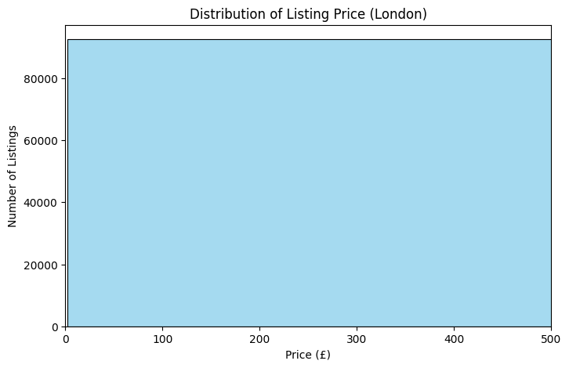

Fig. B — Room Type Count Plot
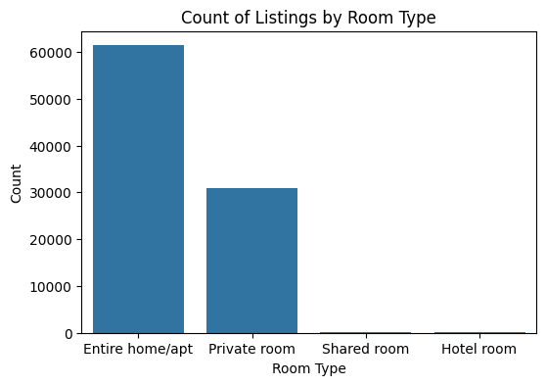 e

Fig. C — Average Price by Borough
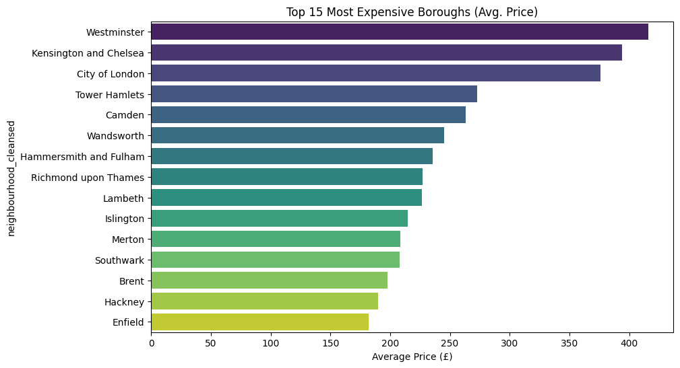

Fig. D — Correlation Heatmap
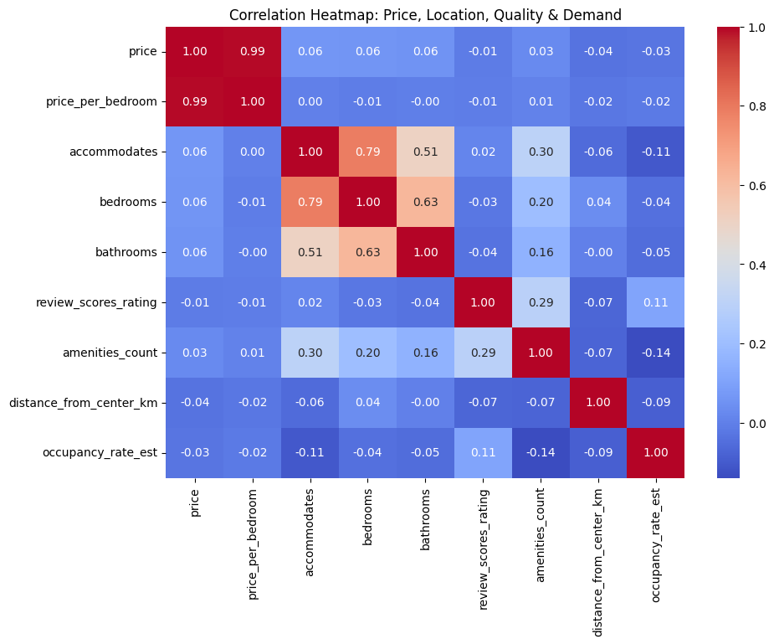

Fig. E — Interactive Price Map
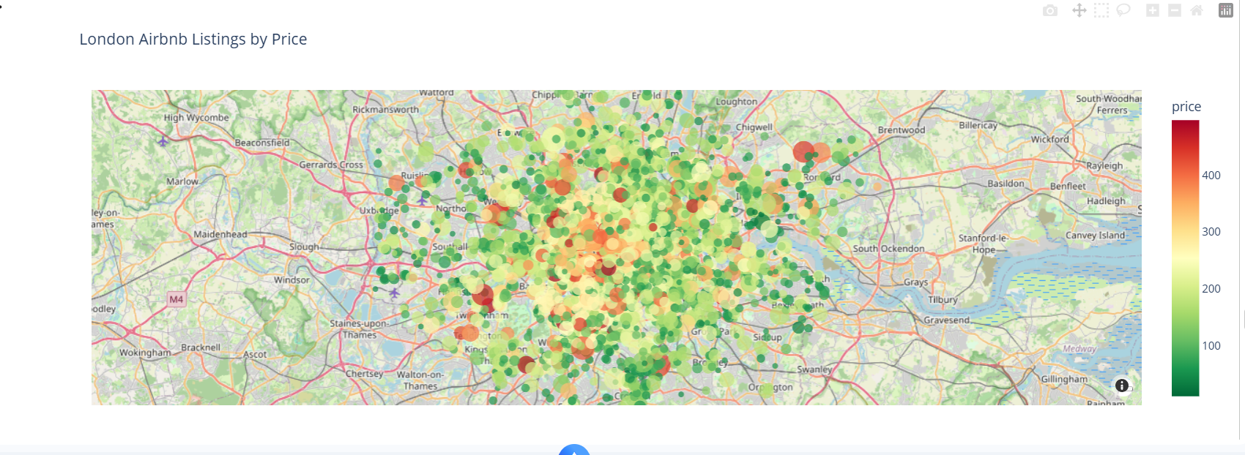

I.2 Statistical & Model Results Screenshots
Fig. F — Boxplot / Outlier Detection
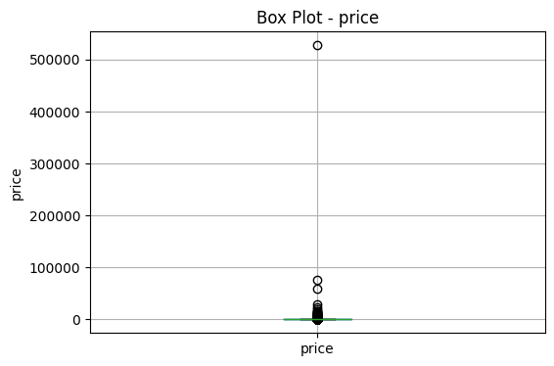 sed

Fig. G — Hypothesis Test Output

Fig. H — Model Comparison Output

I.3 Dashboard Screenshots
Fig. J — KPI Summary Snapshot
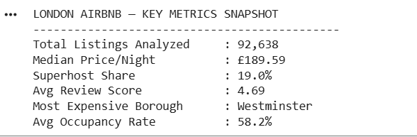

📷 SCREENSHOT PLACEHOLDER
Fig. K — Treemap (Borough Volume vs. Price)
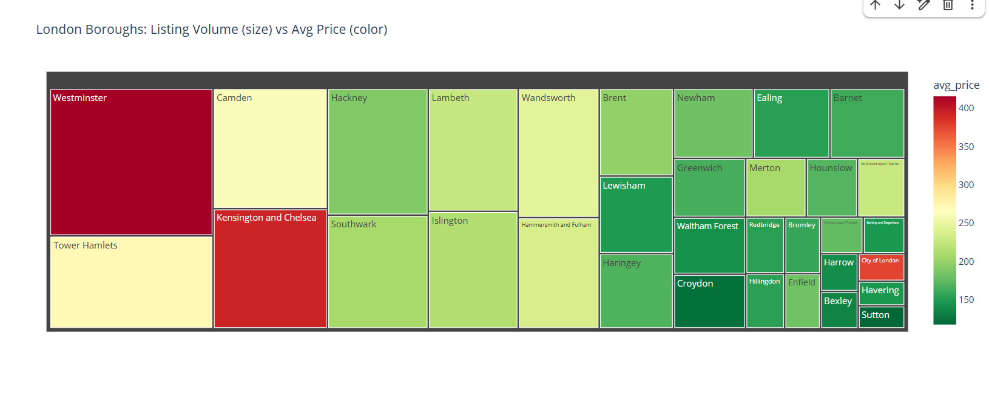

Fig. L — PRICE vs REVIEW SCORE
